|  |  |
| --- | --- |
| **EXPT NO: 9**  **DATE:** | **Explore the features of Power BI Desktop** |

**AIM:**

To explore the features of Power BI Desktop

**Steps:**

**Step 1 :** Start Power BI Desktop

**Step 2 :** Connect to data.

**Step 3 :** Transform and clean data to create a data model.

**Step 4 :** Create visuals, such as charts or graphs that provide visual representations of the data.

**Step 5:** Create reports that are collections of visuals on one or more report pages.

**Step 6 :** Share reports with others by using the Power BI service.

**Step 7 :** Save the file in desired location

**Step 8 :** Close the Power BI Desktop application

**Explore the features of Power BI Desktop**

**What is Power BI Desktop?**

Power BI Desktop is a free application you install on your local computer that lets you connect to, transform, and visualize your data. With Power BI Desktop, you can connect to multiple different sources of data, and combine them (often called modeling) into a data model. This data model lets you build visuals, and collections of visuals you can share as reports, with other people inside your organization. Most users who work on business intelligence projects use Power BI Desktop to create reports, and then use the Power BI service to share their reports with others.

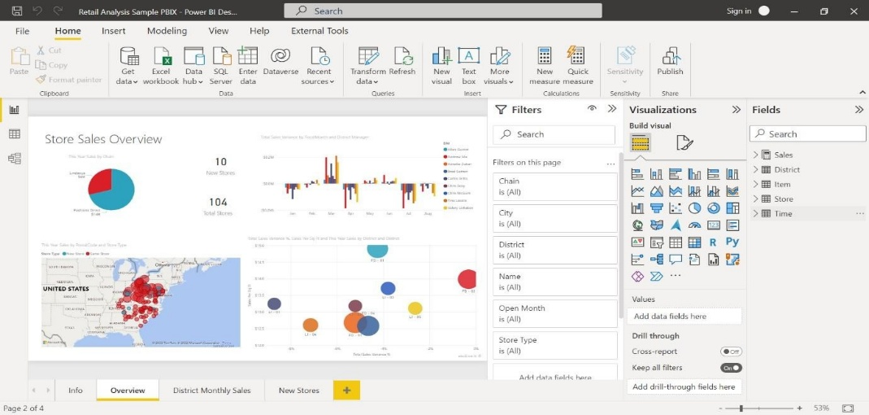

The most common uses for Power BI Desktop are as follows:

* Connect to data.
* Transform and clean data to create a data model.
* Create visuals, such as charts or graphs that provide visual representations of the data.
* Create reports that are collections of visuals on one or more report pages.
* Share reports with others by using the Power BI service.

People who are responsible for such tasks are often considered data analysts (sometimes referred to as analysts) or business intelligence professionals (often referred to as report creators). Many people who don't consider themselves an analyst or a report creator use Power BI Desktop to create compelling reports, or to pull data from various sources. They can build data models, and then share the reports with their coworkers and organizations.

**Important**

Power BI Desktop is updated and released on a monthly basis, incorporating customer feedback and new features. Only the most recent version of Power BI Desktop is supported; customers who contact support for Power BI Desktop will be asked to upgrade to the most 59 recent version. You can get the most recent version of Power BI Desktop from the Windows Store, or as a single executable containing all supported languages that you download and install on your computer.

There are three views available in Power BI Desktop, which you select on the left side of the canvas. The views, shown in the order they appear, are as follows:

* **Report:** You create reports and visuals, where most of your creation time is spent.
* **Data:** You see the tables, measures, and other data used in the data model associated with your report, and transform the data for best use in the report's model.
* **Model:** You see and manage the relationships among tables in your data model.

The following image shows the three views, as displayed along the left side of the canvas:

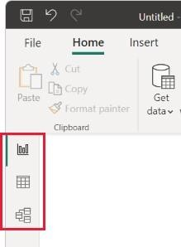

**Connect to data**

To get started with Power BI Desktop, the first step is to connect to data. There are many different data sources you can connect to from Power BI Desktop.

To connect to data:

1. From the **Home** ribbon, select **Get Data > More.**

The **Get Data** window appears, showing the many categories to which Power BI Desktop can connect.

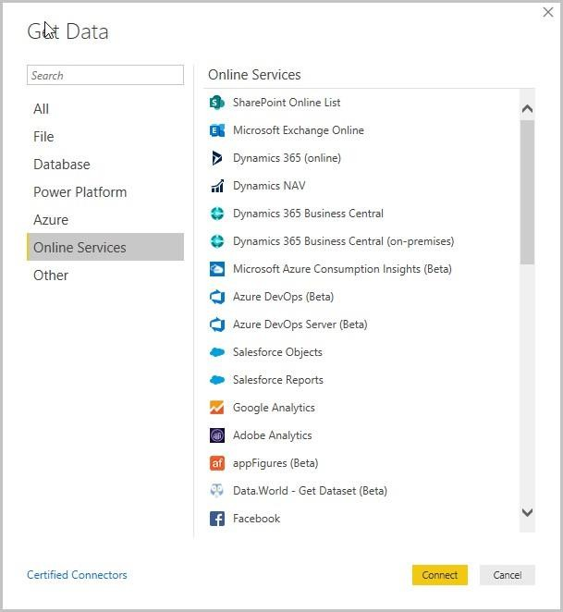

1. When you select a data type, you're prompted for information, such as the URL and credentials, necessary for Power BI Desktop to connect to the data source on your behalf.

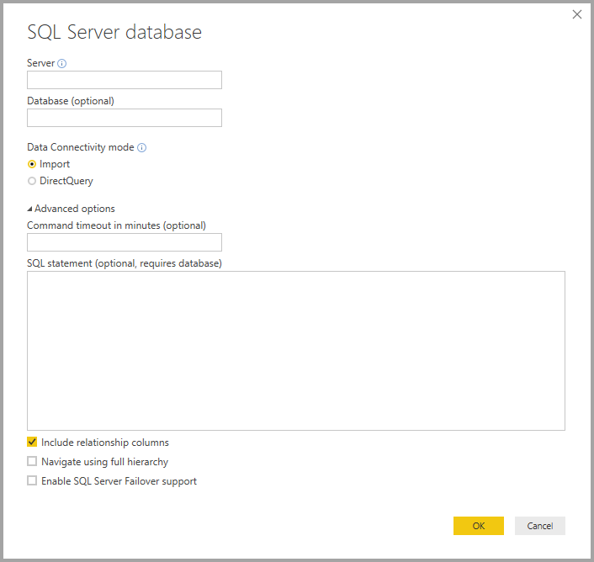

3.After you connect to one or more data sources, you may want to transform the data so it's useful for you.

**Transform and clean data, create a model**

In Power BI Desktop, you can clean and transform data using the built-in Power Query Editor. With Power Query Editor, you make changes to your data, such as changing a data type, removing columns, or combining data from multiple sources. It's like sculpting: you start with a large block of clay (or data), then shave off pieces or add others as needed, until the shape of the data is how you want it.

To start Power Query Editor:

• On the **Home** ribbon, in the **Queries** section, select **Transform data.**

The **Power Query** Editor window appears.

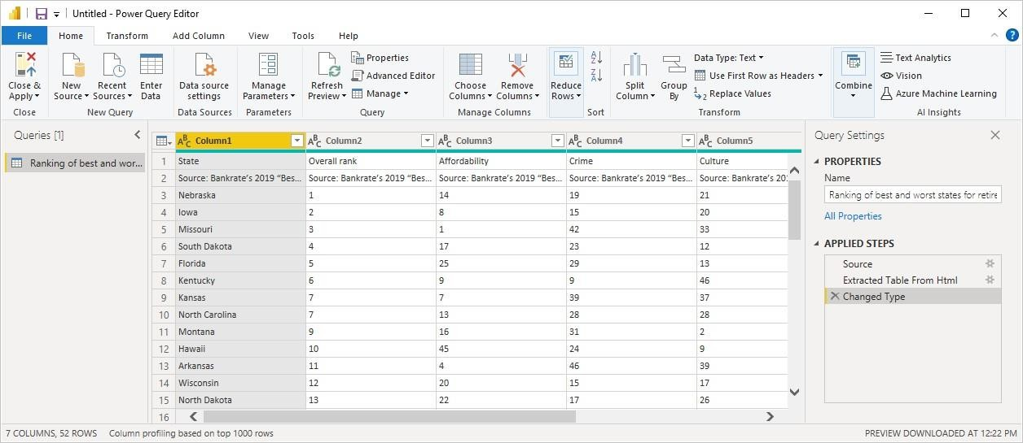

Each step you take in transforming data (such as renaming a table, transforming a data type, or deleting a column) is recorded by Power Query Editor. Every time this query connects to the data source, those steps are carried out so that the data is always shaped the way you specify. 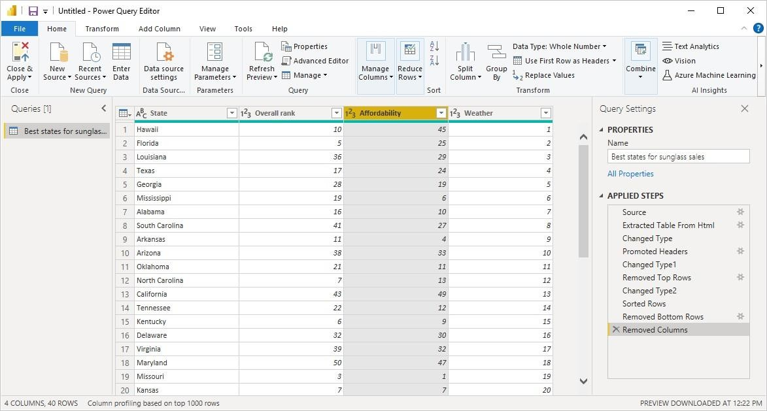

Once your data is how you want it, you can create visuals.

**Create visuals**

After you have a data model, you can drag fields onto the report canvas to create visuals. A visual is a graphic representation of the data in your model. There are many different types of 63 visuals to choose from in Power BI Desktop. The following visual shows a simple column chart.

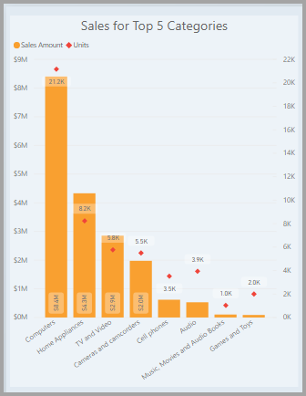

To create or change a visual:

* From the **Visualizations** pane, select the Build visual icon.

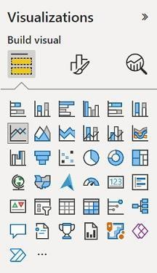

If you already have a visual selected on the report canvas, the selected visual changes to the type you selected.

If no visual is selected on the canvas, a new visual is created based on your selection.

**Create reports**

More often, you'll want to create a collection of visuals that show various aspects of the data you've used to create your model in Power BI Desktop. A collection of visuals, in one Power BI Desktop file, is called a report. A report can have one or more pages, just like an Excel file can have one or more worksheets.

With Power BI Desktop you can create complex and visually rich reports, using data from multiple sources, all in one report that you can share with others in your organization.

In the following image, you see the first page of a Power BI Desktop report, named Overview, as seen on the tab near the bottom of the image.

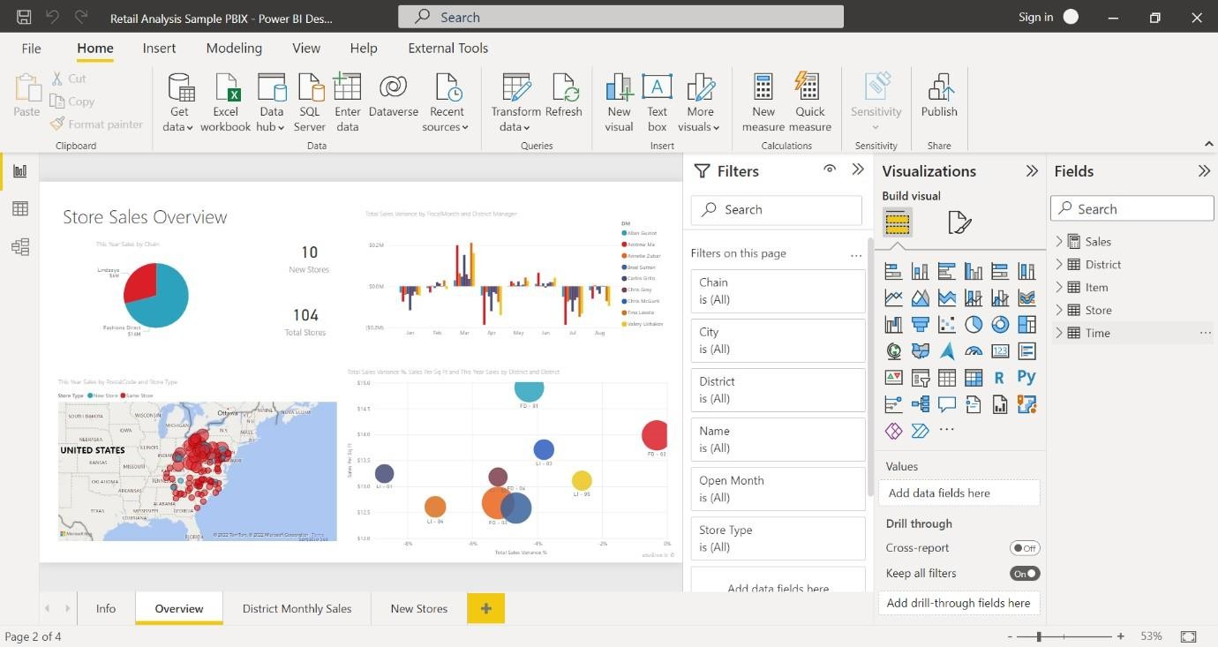

**Share reports**

After a report is ready to share with others, you can publish the report to the Power BI service, and make it available to anyone in your organization who has a Power BI license.

To publish a Power BI Desktop report:

1.Select **Publish** from the **Home** ribbon.

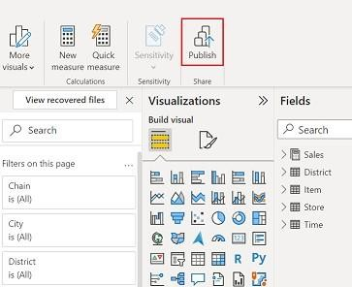

Power BI Desktop connects you to the Power BI service with your Power BI account.

2. You're prompted to select where in the Power BI service you'd like to share the report. For example, your workspace, a team workspace, or some other location in the Power BI service.

**Following are some of the features of Power BI –**

**1. Power BI Desktop**

Power BI Desktop is free software that you can download and install, and it allows you to build reports by accessing data easily. For using Power BI desktop, you do not need advanced report designing, or query skills to build a report.

**2. Stream Analytics**

Power BI's primary advantage is its support stream analytics. From factory sensors to social media sources, Power BI assists in real-time analytics to make timely decisions.

**3. Multiple Data Sources**

Support for various data sources is one of the vital features of Power BI. You can access various sources of data such as Excel, CSV, SQL Server, Web files, etc. to create interactive visualizations.

4**. Custom Visualization**

While dealing with complex data, Power BI's default standard might not be enough in some cases. In that case, you can access the custom library of visualization that meets your needs.

**RESULT:**

The features of Power BI explored successfully and displayed desired output in neat format.

|  |  |
| --- | --- |
| **PERFORMANCE(25)** |  |
| **VIVA-VOCE(10)** |  |
| **RECORD(15)** |  |
| **TOTAL(50)** |  |

|  |  |
| --- | --- |
| **EXPT NO: 10**  **DATE:** | **PREPARE AND LOAD DATA IN POWER BI DESKTOP** |

**AIM:**

To Prepare & Load data in Power BI Desktop

**Steps:**

**Step 1 :** Start Power BI Desktop

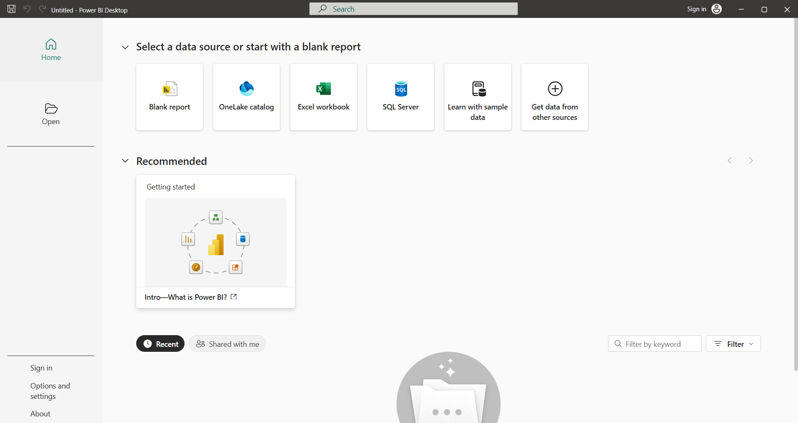

**Step 2 :** Goto to home menu , select get data and then choose excel worksheet

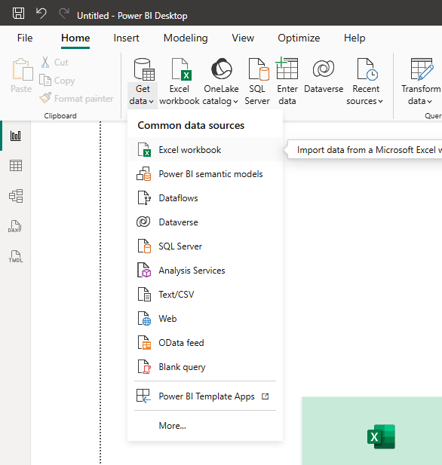

**Step 3 :** Select your file to load into Power Bi application and press load button

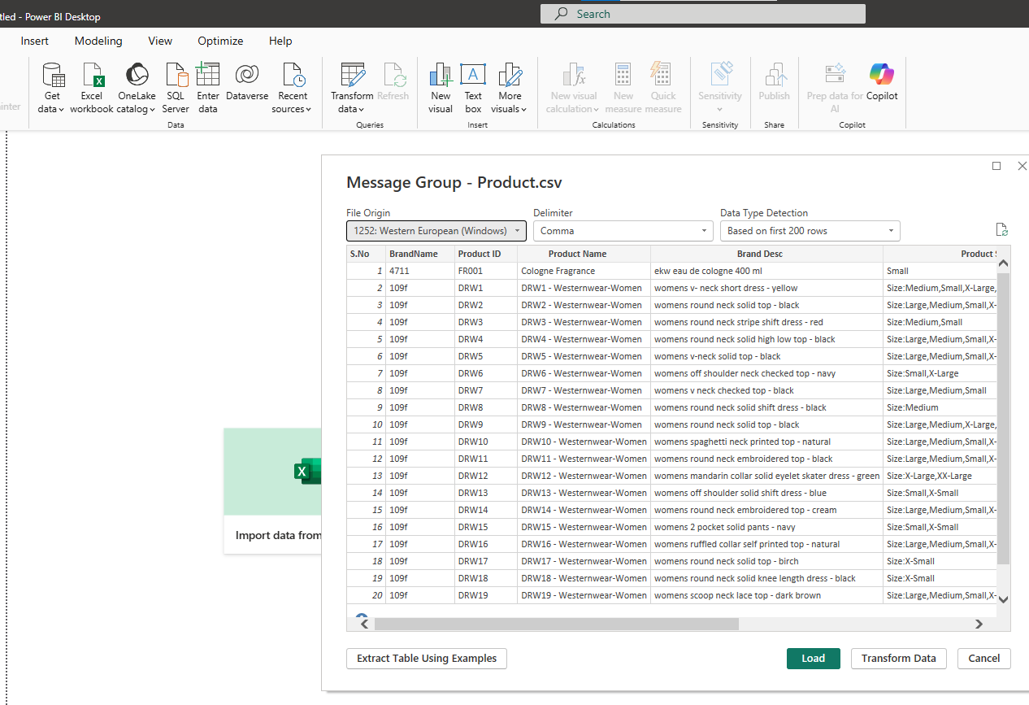

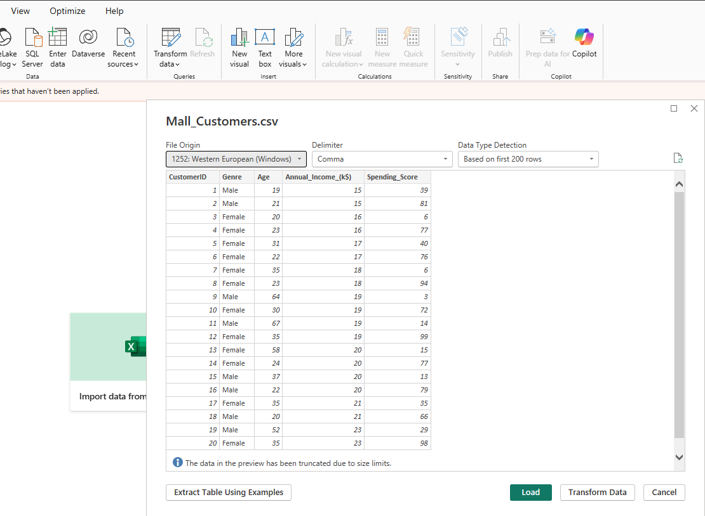

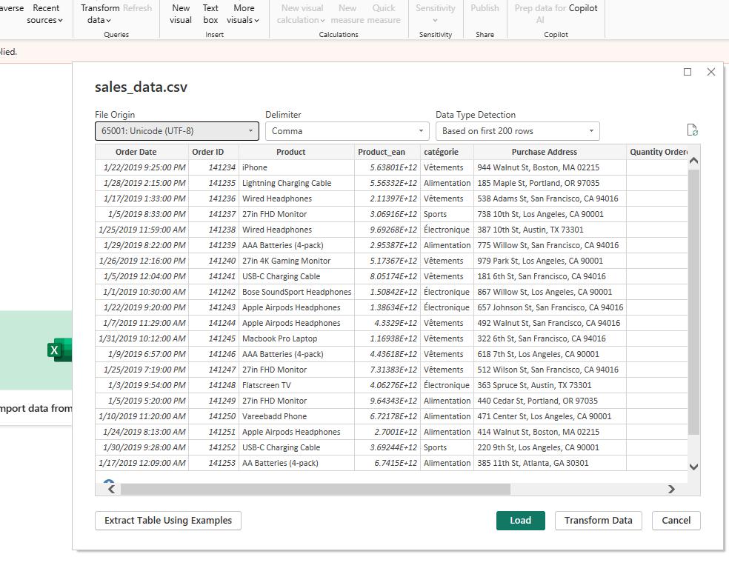

**Step 4 :** Now the file is loaded, perform some operations like Remove rows

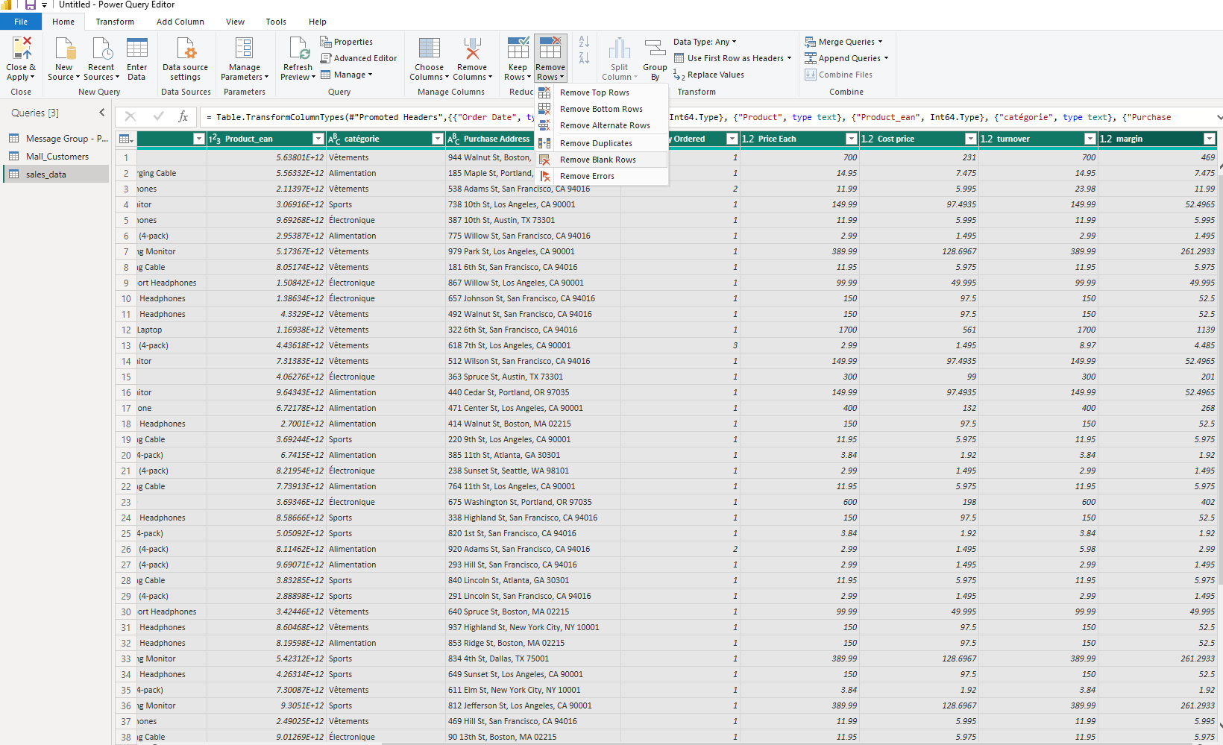

**Step 5:** Create new column if desire using the custom column.

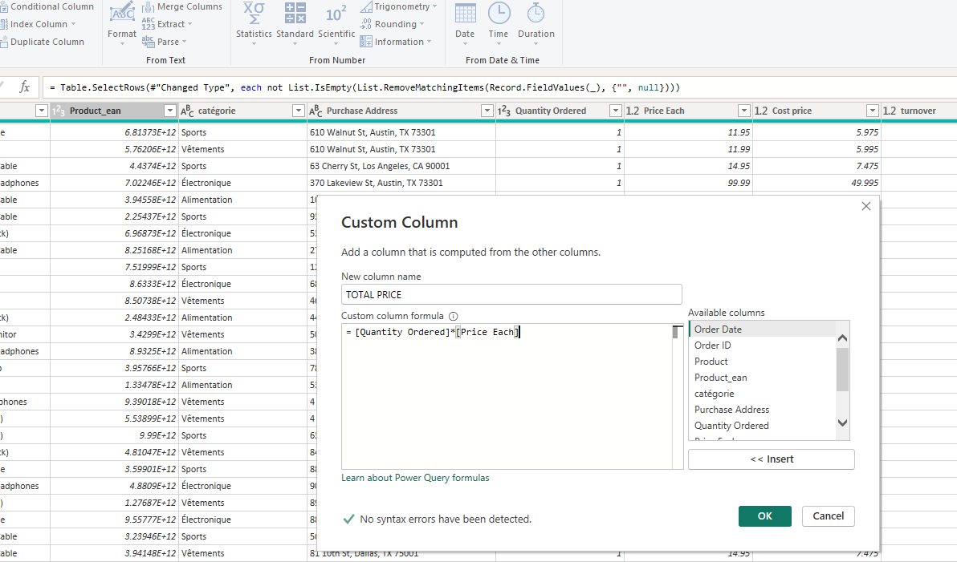

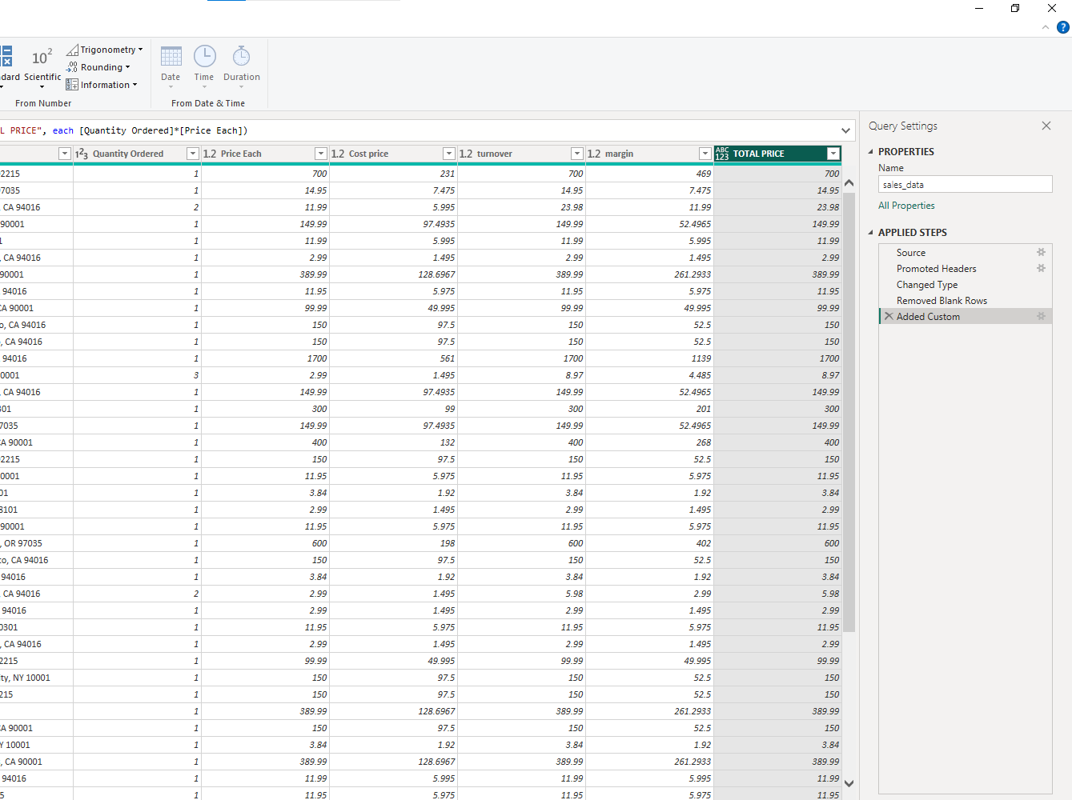

OUTPUT:

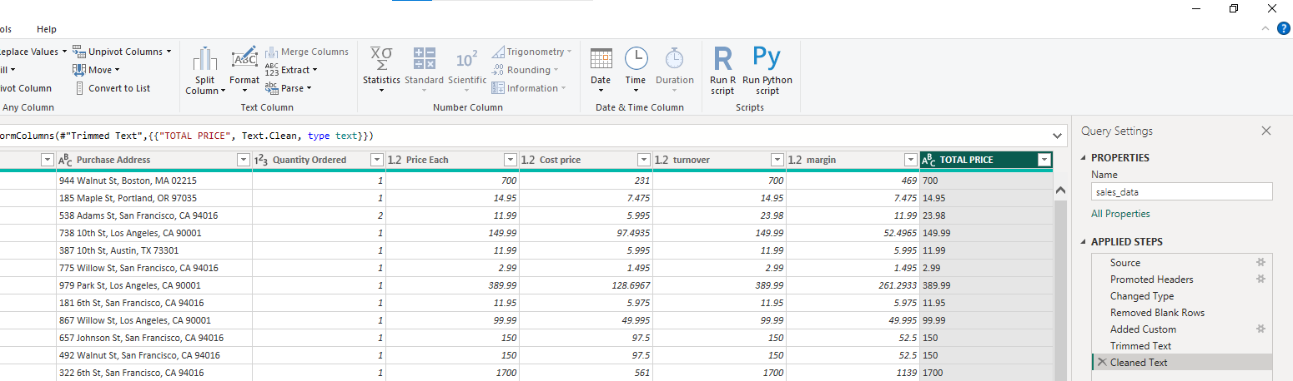

**RESULT:**

The Excel data sheet was prepared and loaded successfully into Power BI Desktop and displayed desired output in neat format.

|  |  |
| --- | --- |
| **PERFORMANCE(25)** |  |
| **VIVA-VOCE(10)** |  |
| **RECORD(15)** |  |
| **TOTAL(50)** |  |

|  |  |
| --- | --- |
| **Exercise 11**  **Date:** | **Develop Data Model** |

**Aim:**  
To develop a **data model** in Power BI Desktop by importing multiple datasets to create meaningful connections between tables for effective data analysis and visualization.

Steps:

1. Open **Power BI Desktop**.

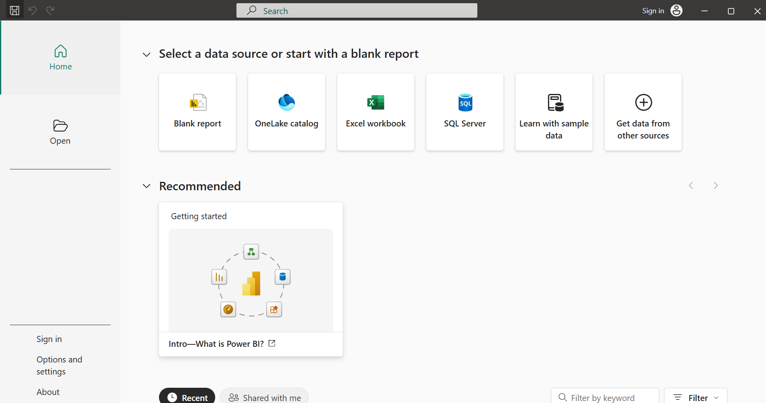

1. Go to **Home → Get Data** and import your dataset.

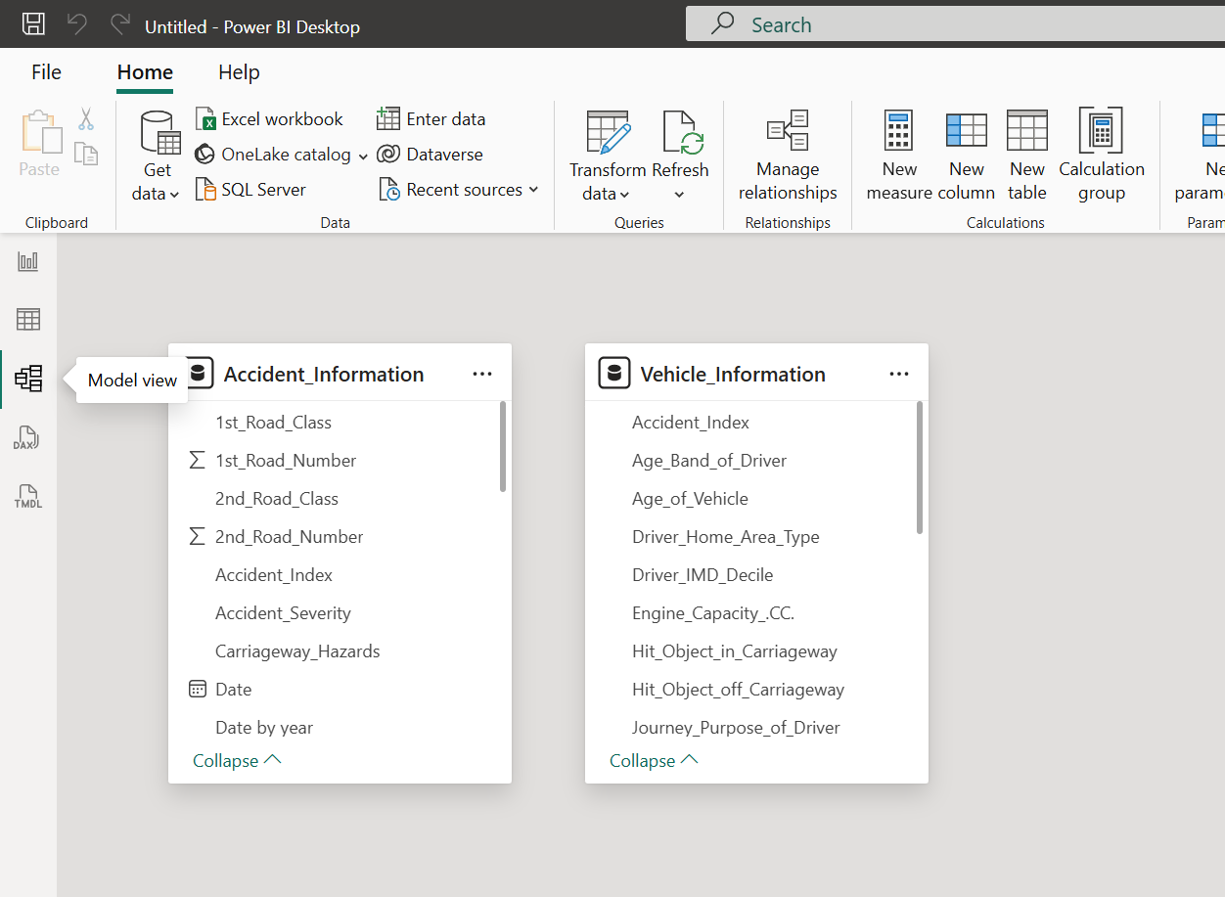

1. Create **relationships** between tables by dragging and dropping matching key fields and Ensure the relationship type is correct (One-to-Many or Many-to-One).
2. One to Many:

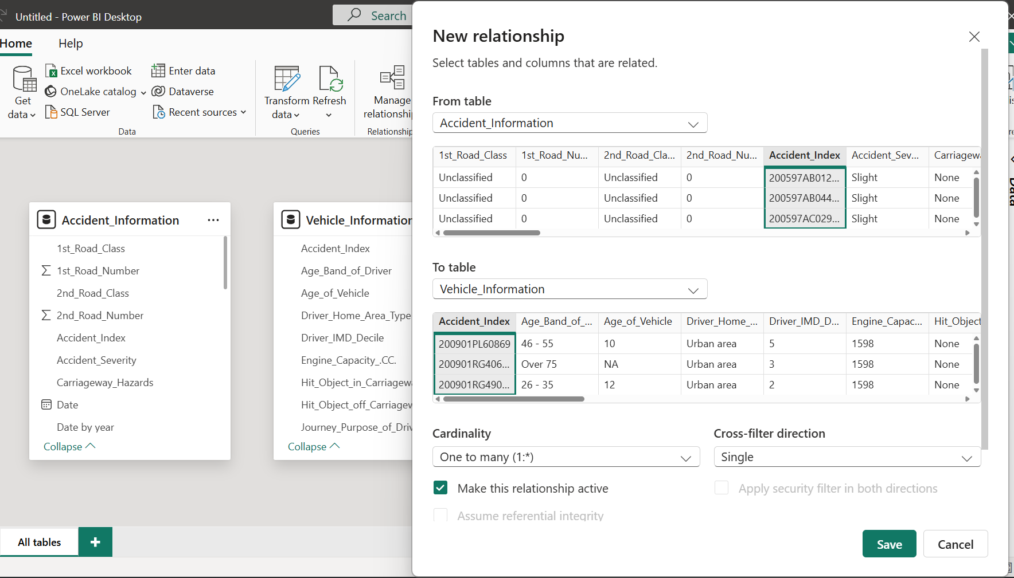

1. Many to Many: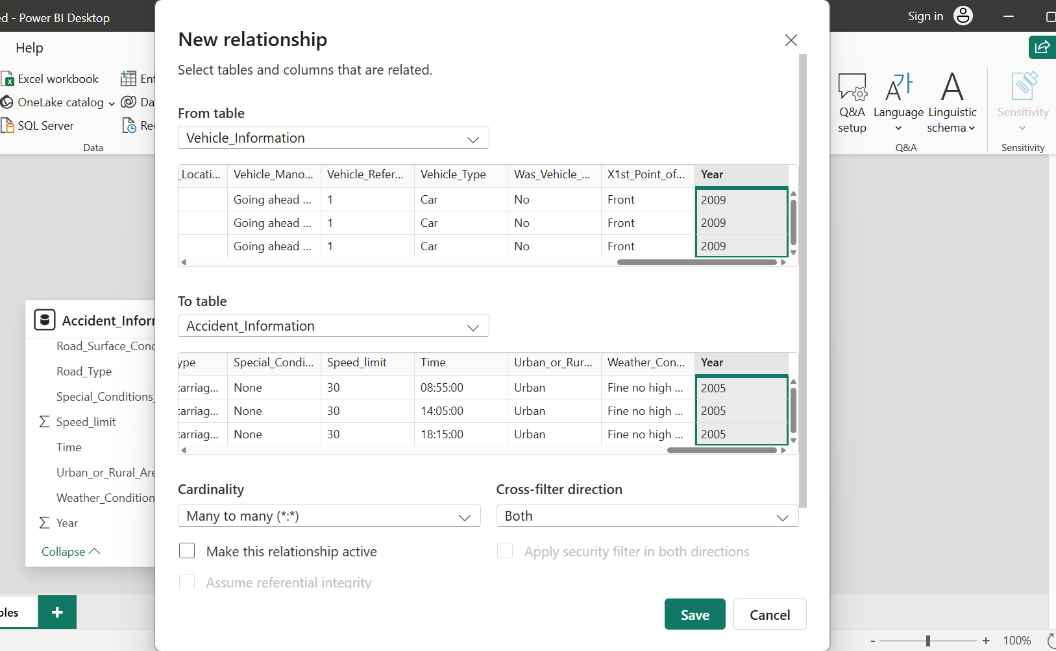 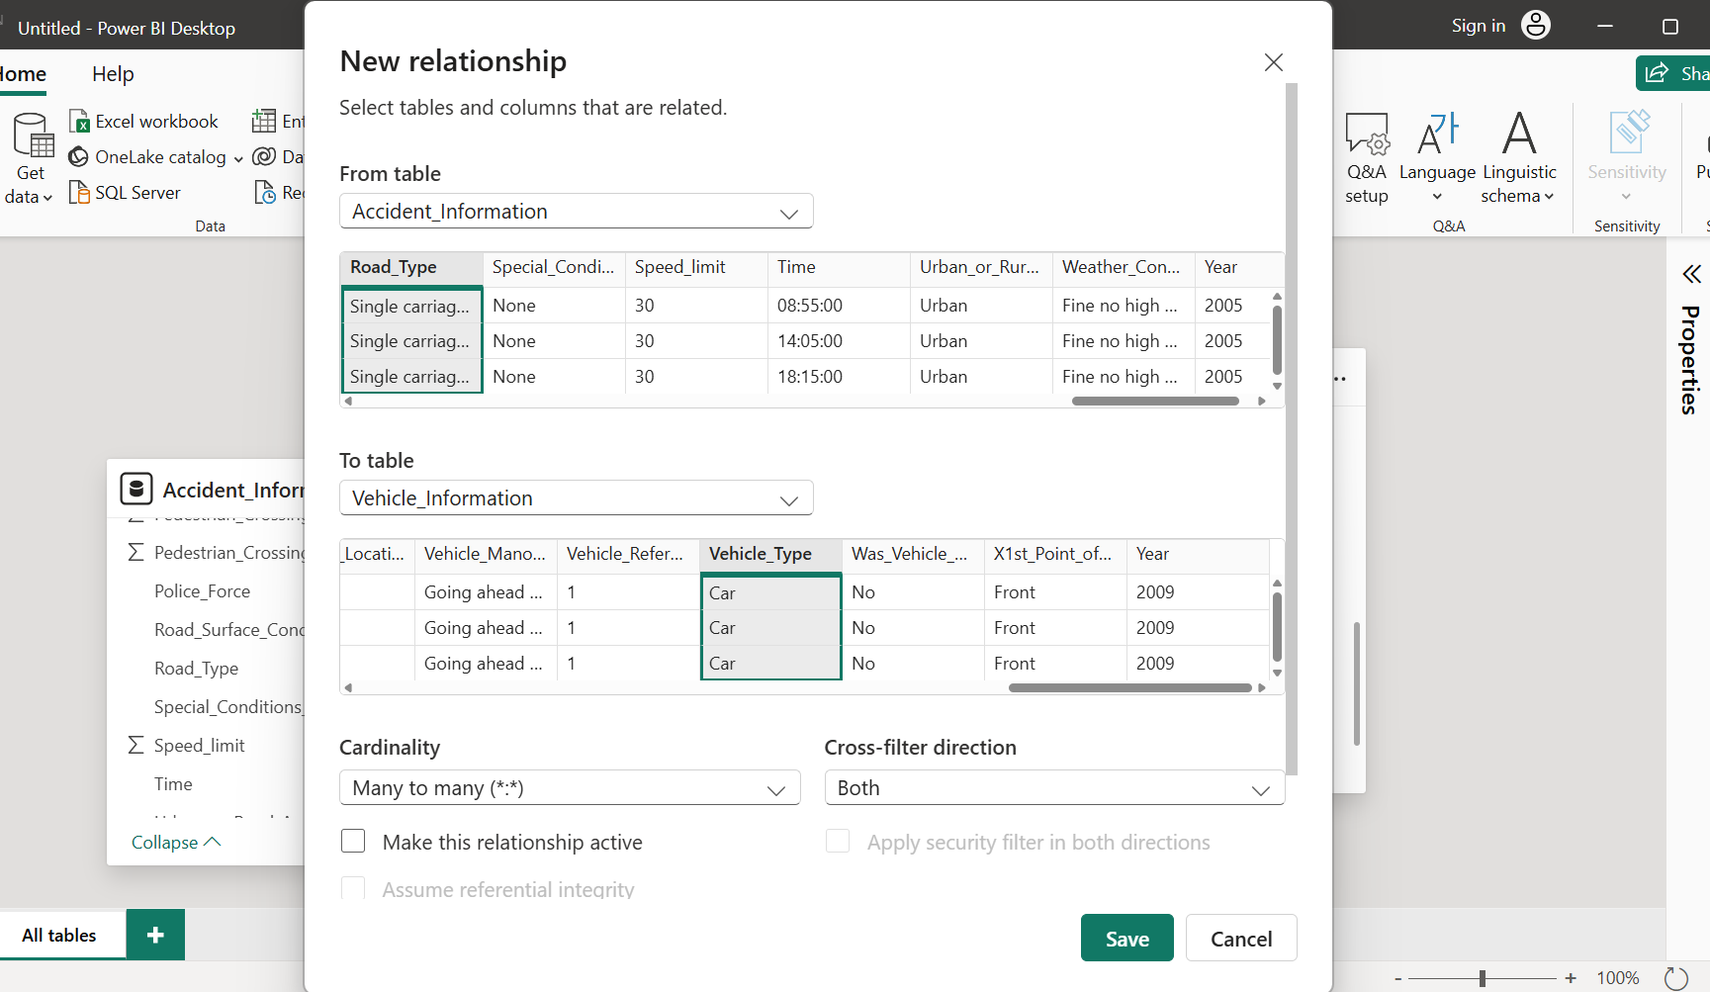
2. Save the model once relationships are properly created and validated.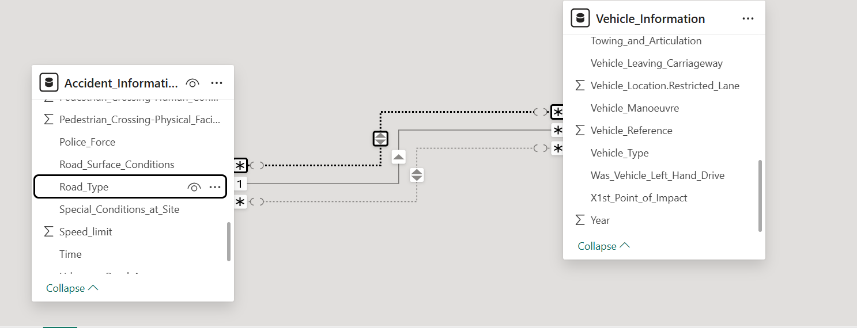

**Result:**

Thus, a well-structured **data model** was successfully developed in Power BI Desktop by establishing relationships between tables, enabling efficient data analysis and visualization through connected datasets.

|  |  |
| --- | --- |
| Performance (25) |  |
| Viva Voce (10) |  |
| Record (15) |  |
| Total (50) |  |

|  |  |
| --- | --- |
| **Exercise 12**  **Date:** | **Perform DAX calculations** |

Aim:

To create calculated columns and measures using DAX (Data Analysis Expressions) in Power BI Desktop for performing data analysis and deriving insights.

Steps:

1. Open the Power BI file containing the developed data model.

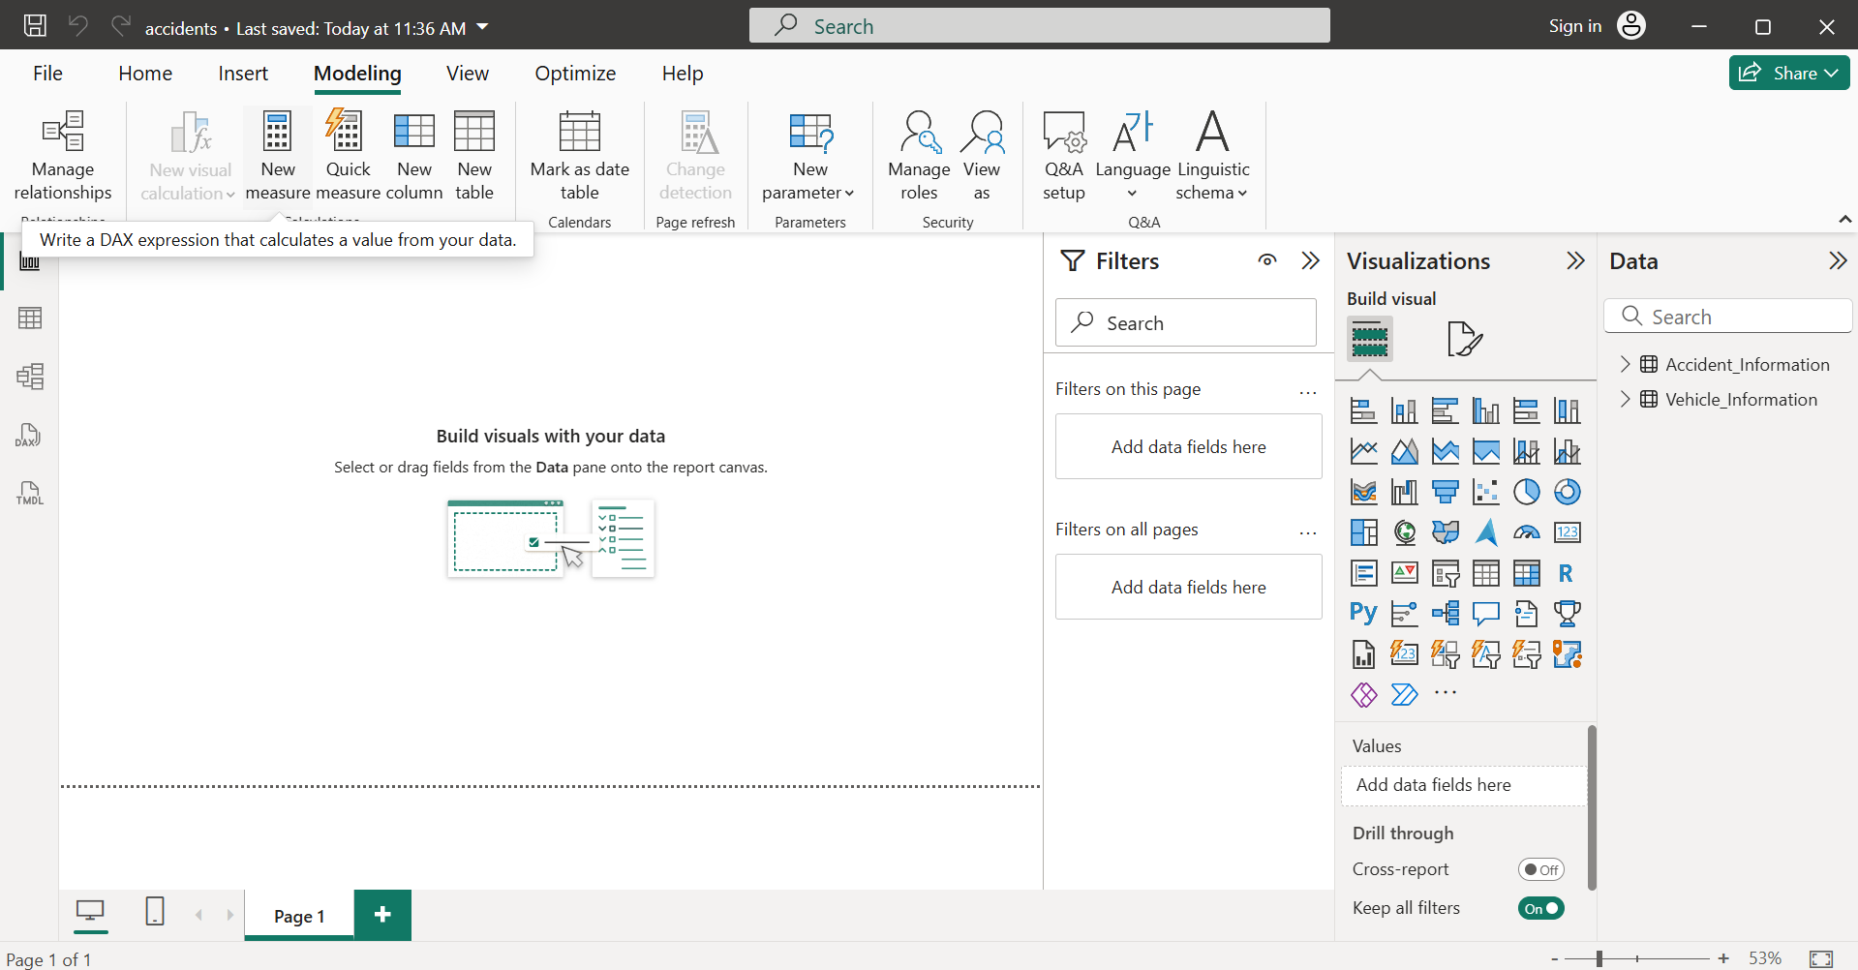

1. Go to the Data View (table icon on the left sidebar).

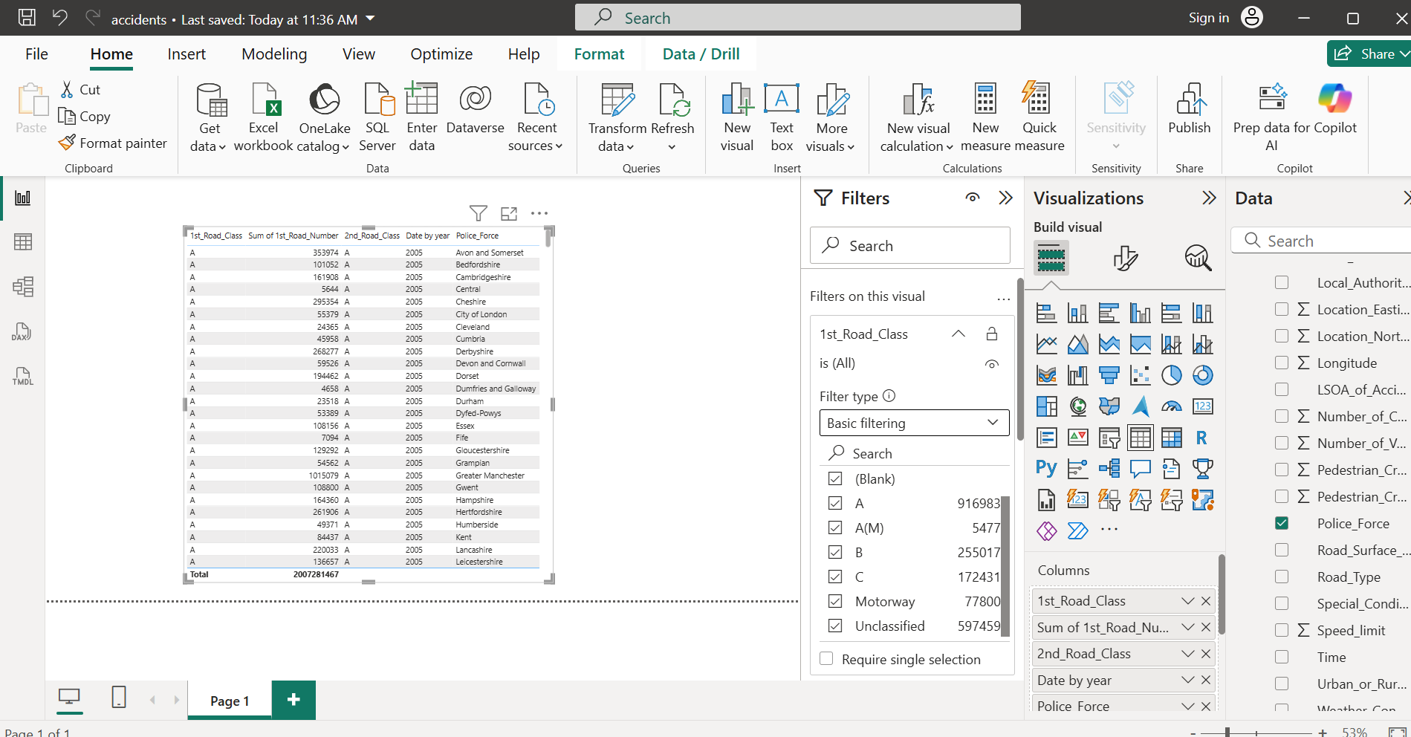

1. Select the table where you want to add a calculated column.

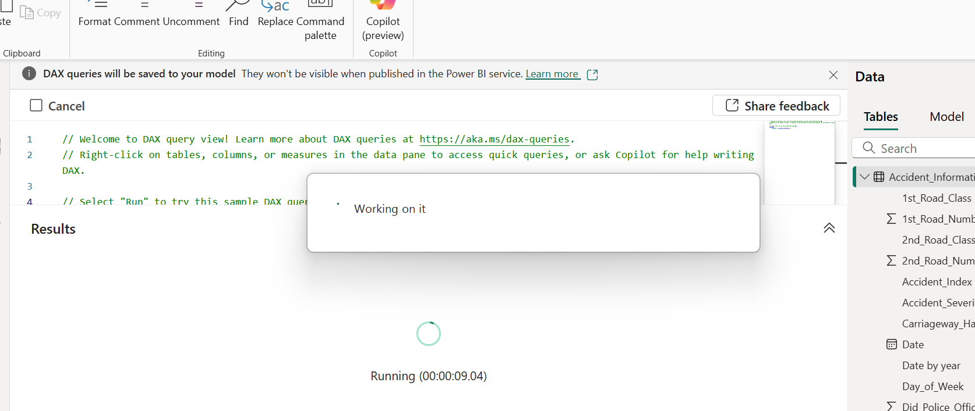

1. Enter a DAX formula and press Enter.

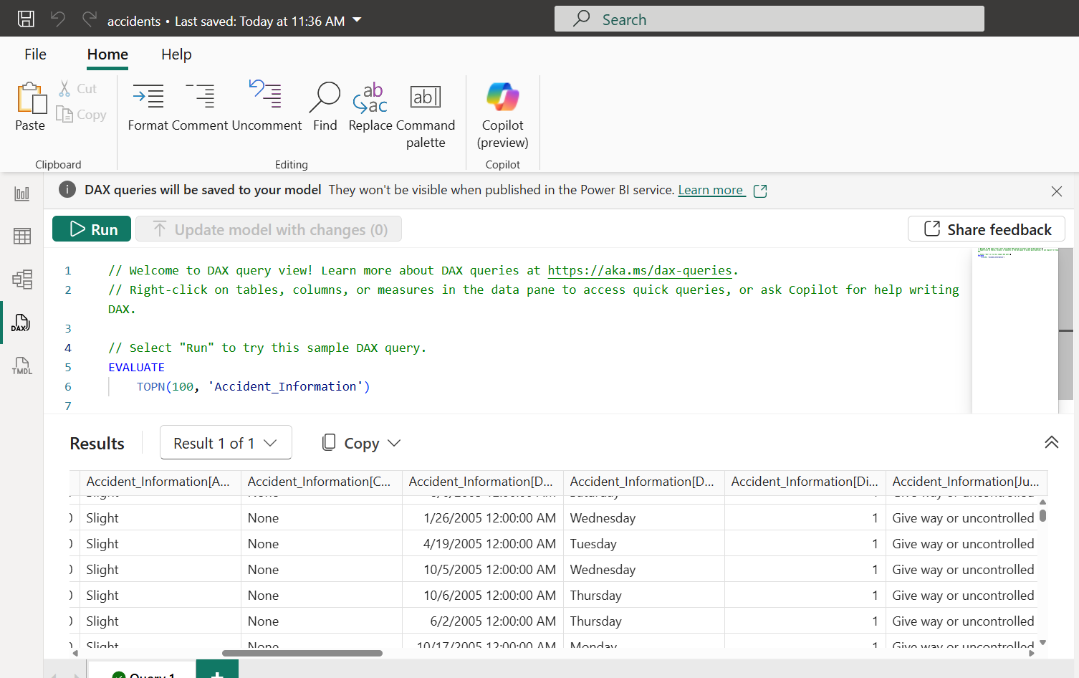

1. To create a measure, click Modeling → New Measure.

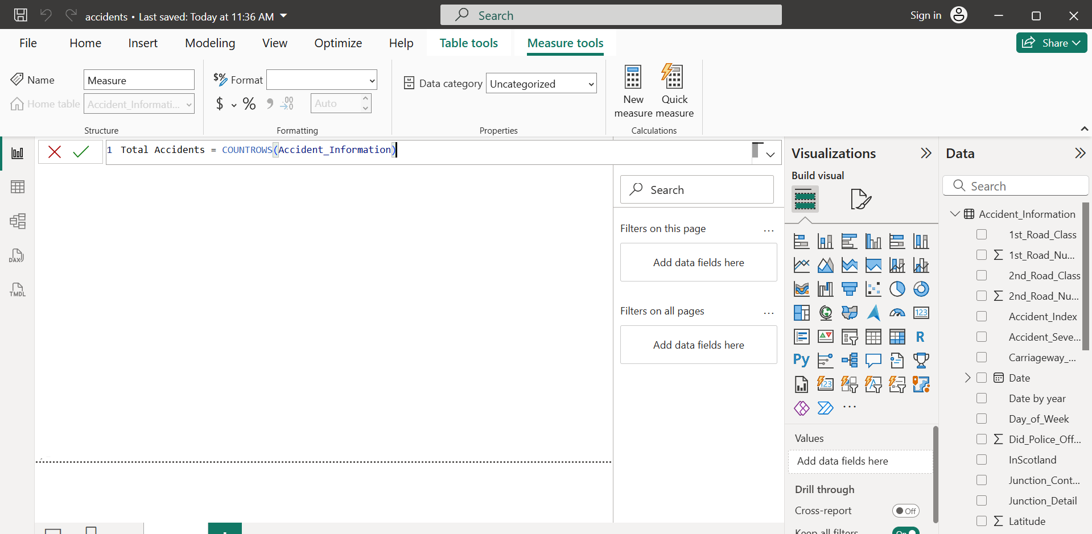

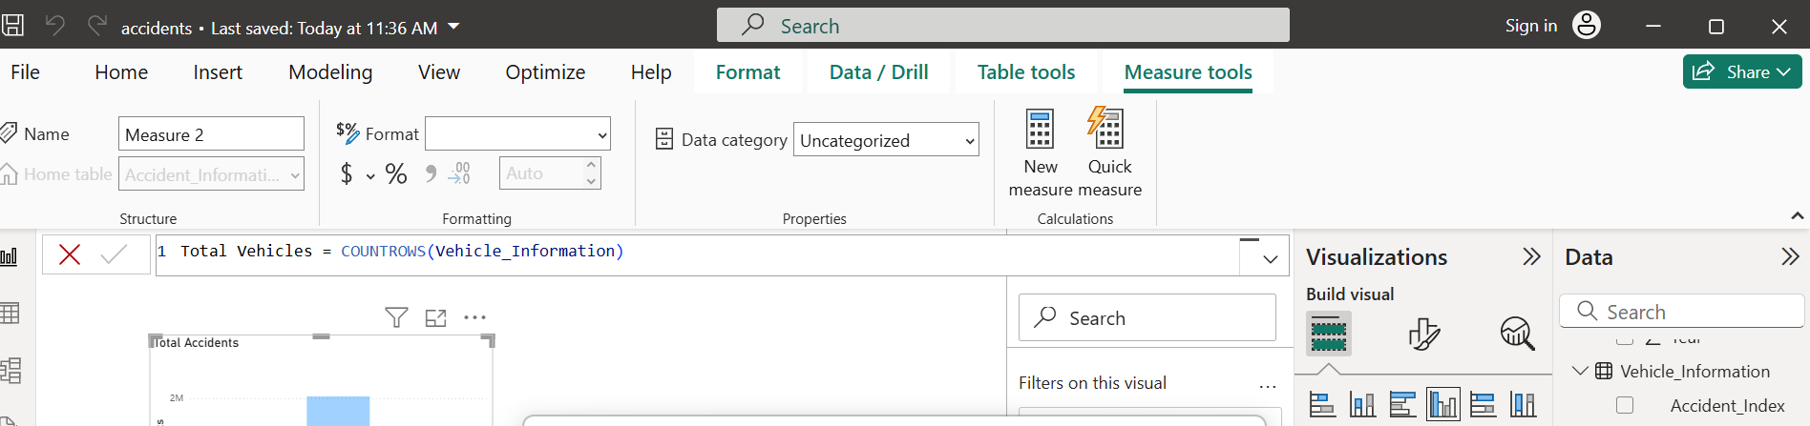

1. Use these columns or measures in Visualizations (like charts or cards) to display results.

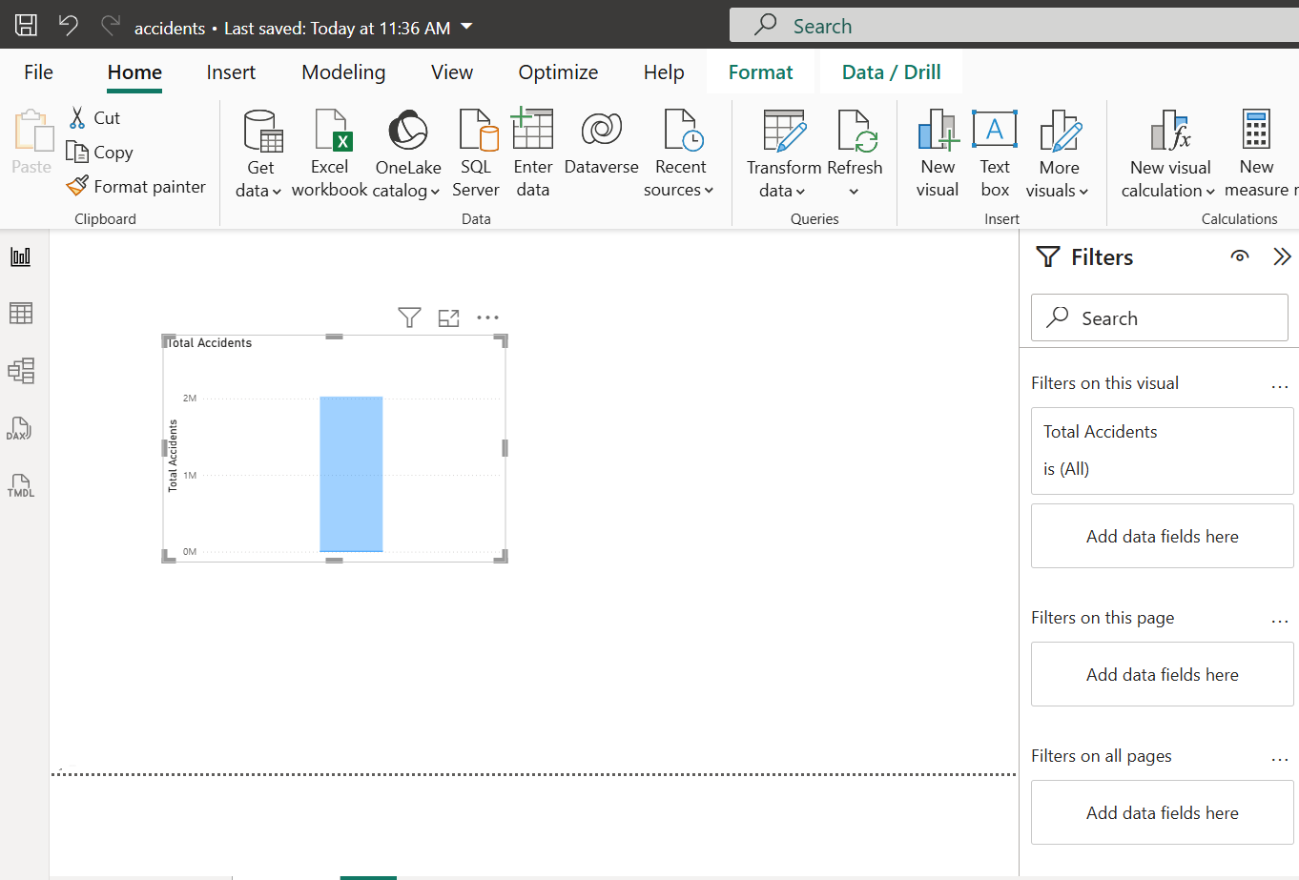

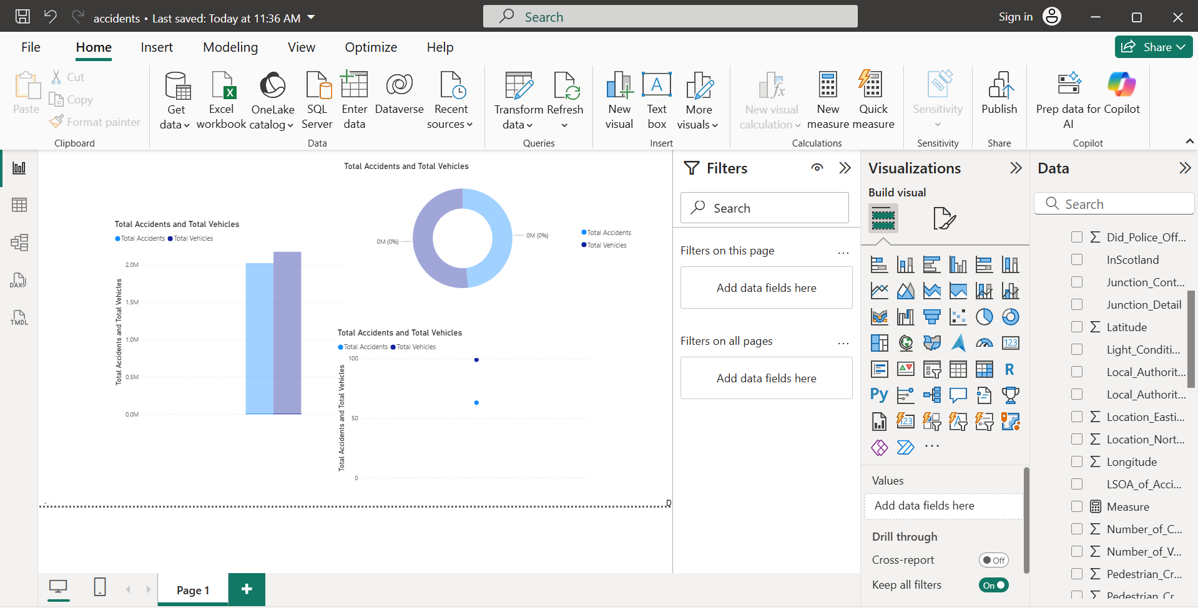

**Result:**  
DAX formulas were successfully created to calculate new values and measures, enabling deeper insights and analytical capabilities within Power BI reports.

|  |  |
| --- | --- |
| Performance (25) |  |
| Viva Voce (10) |  |
| Record (15) |  |
| Total (50) |  |

|  |  |
| --- | --- |
| **Exercise 13**  **Date:** | **Design a report** |

Aim:

To design an interactive and visually appealing report in Power BI Desktop using charts, tables, and filters for effective data visualization and analysis.

Steps:

1. Open the Power BI file containing the data model and DAX calculations.



1. From the Visualizations pane, choose the desired chart type (e.g., bar chart, pie chart, line chart, card, map).

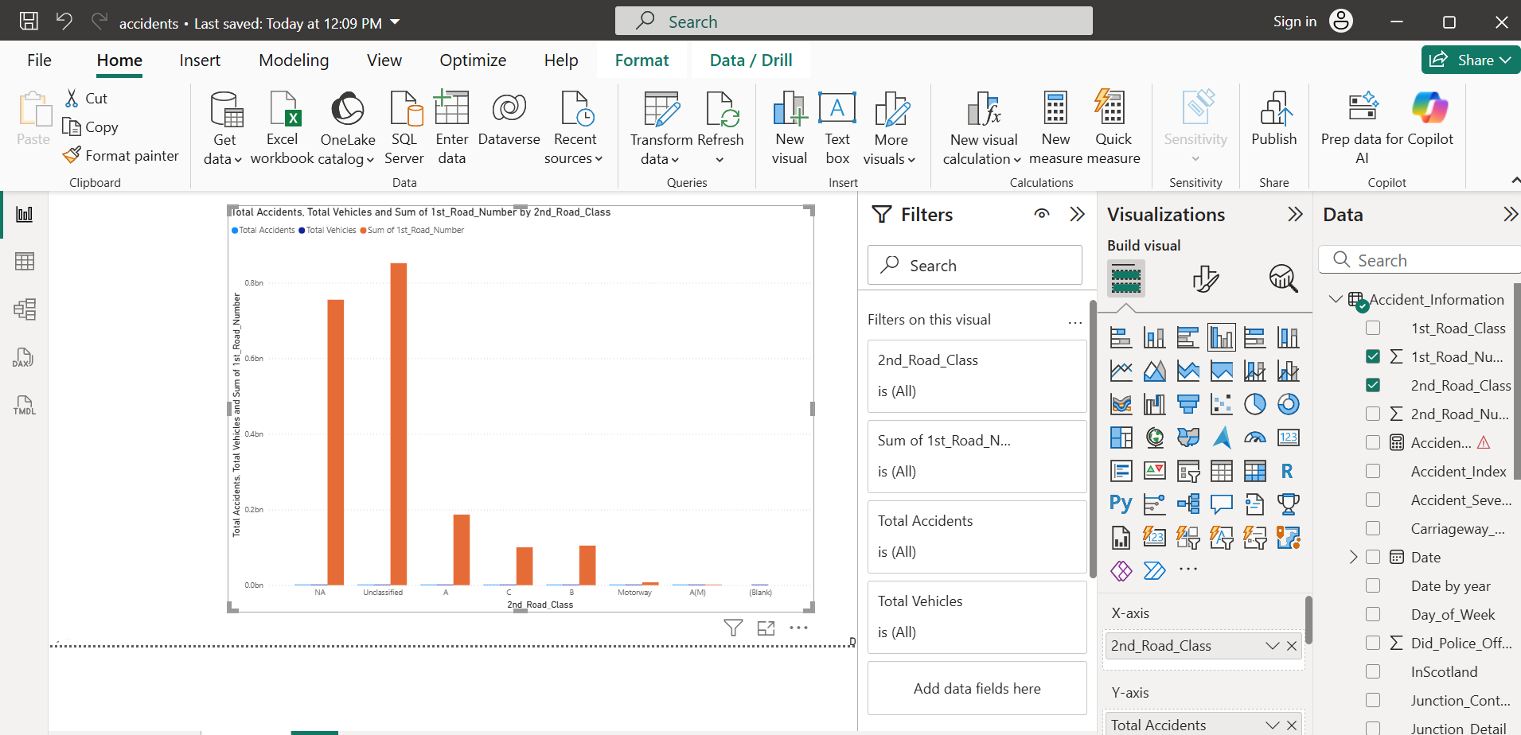

1. Add multiple visuals (charts/tables) to represent different insights.

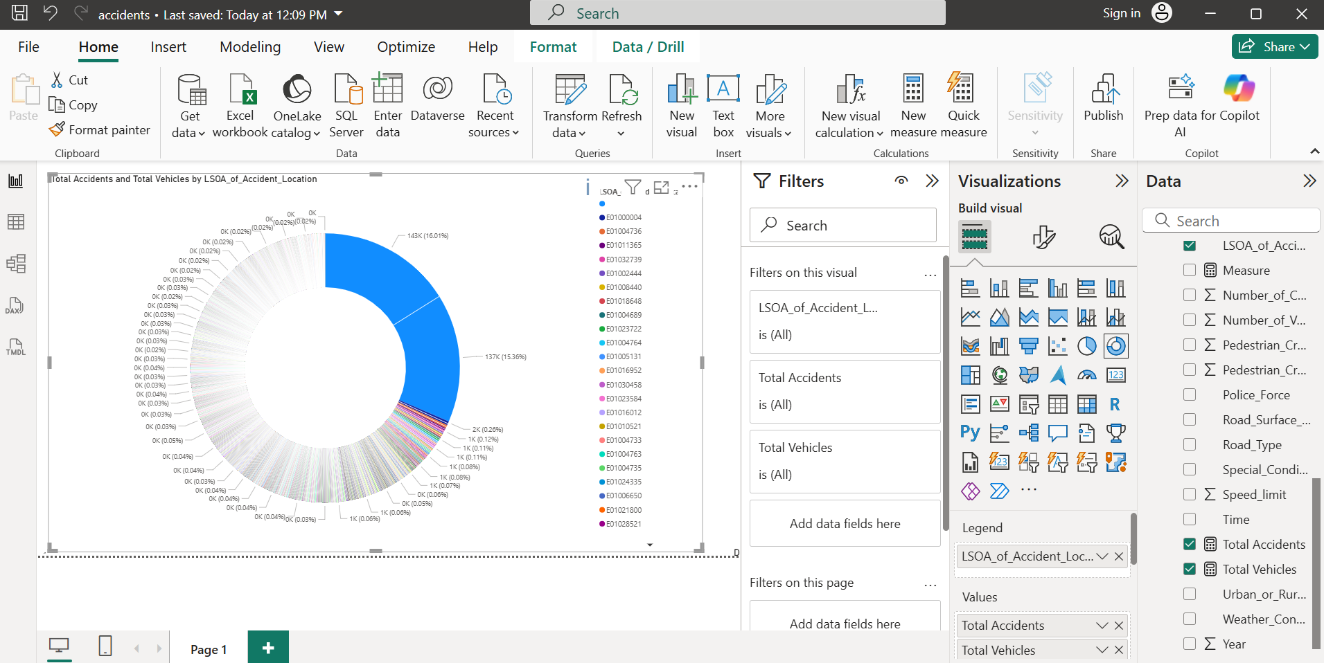

1. Use Slicers or Filters to make the report interactive.

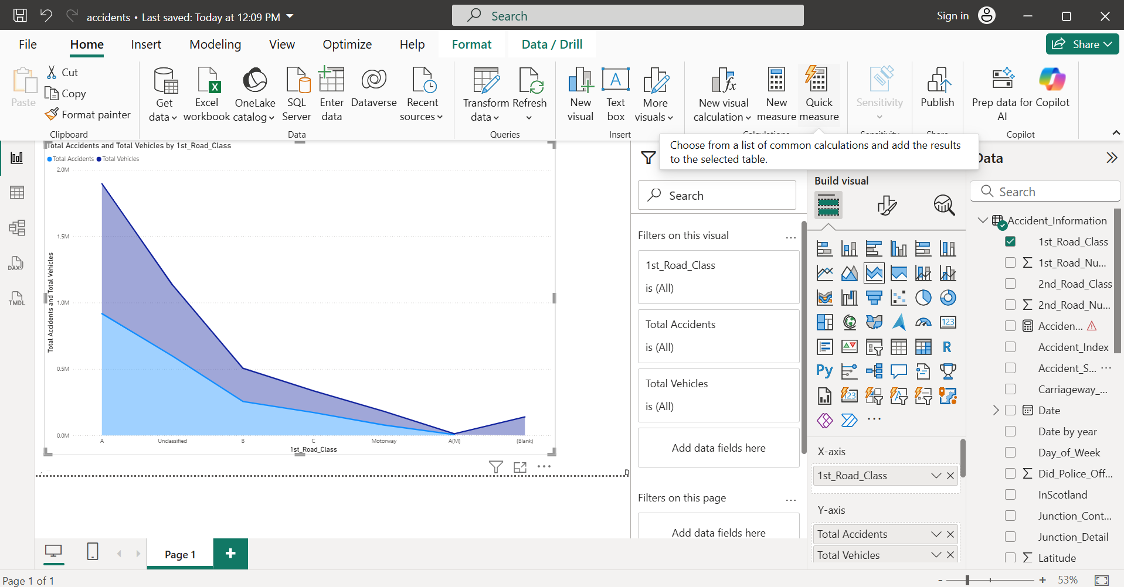

1. Customize visual elements (titles, colors, labels, and legends) for better readability.

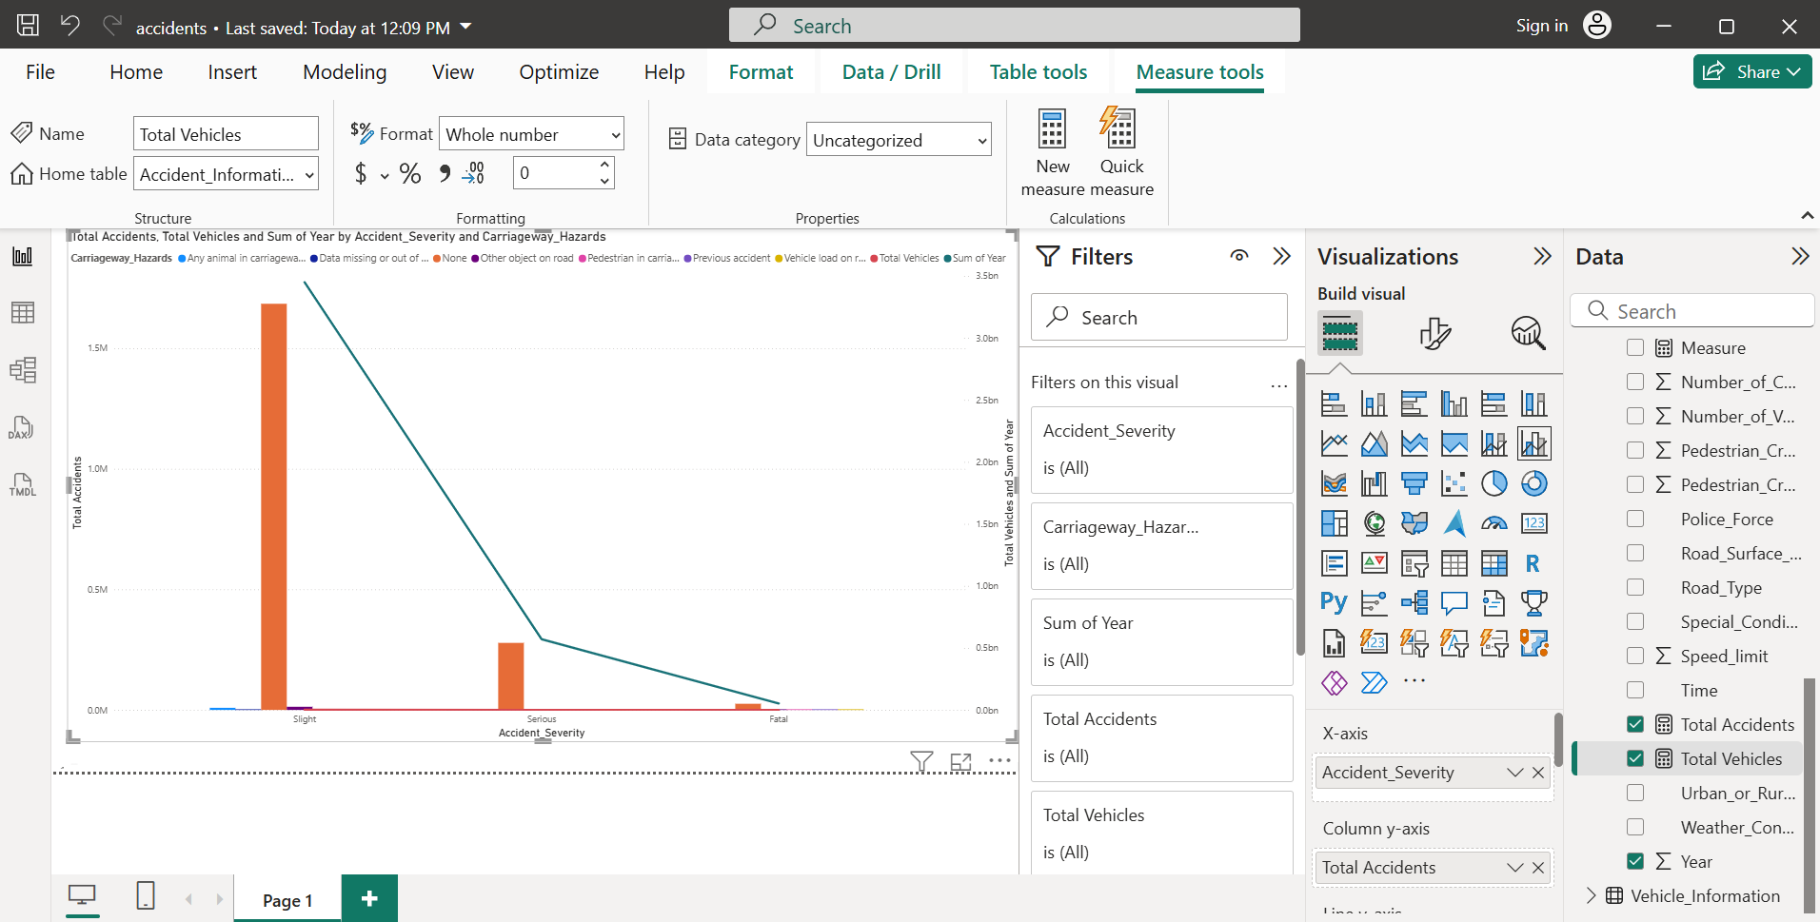

1. Arrange visuals neatly on the canvas for a clear layout.

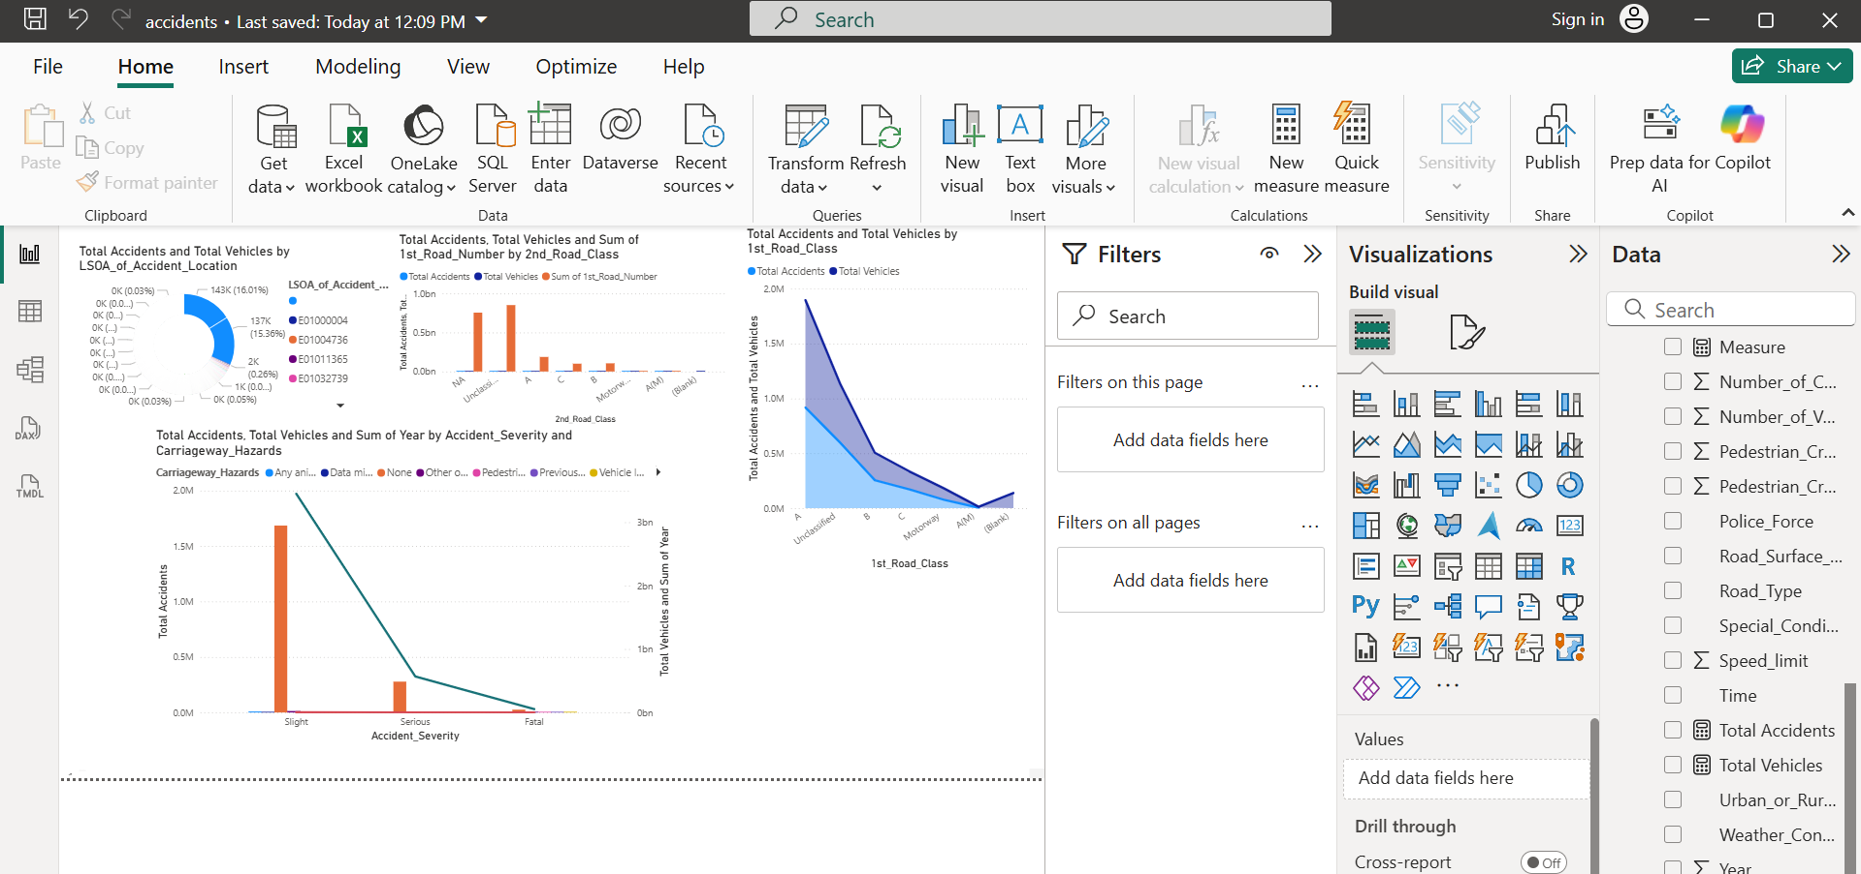

**Result:**  
An interactive and visually appealing **Power BI report** was successfully designed using different visualization tools, enabling effective data interpretation and analysis.

|  |  |
| --- | --- |
| Performance (25) |  |
| Viva Voce (10) |  |
| Record (15) |  |
| Total (50) |  |

|  |  |
| --- | --- |
| **Exercise 14**  **Date:** | **Create a dashboard and perform data analysis** |

**Aim:**

To create an interactive dashboard in Power BI Desktop and perform data analysis using visual insights, filters, and slicers for better decision-making.

**Steps:**

1. Open the Power BI file containing the designed report.Go to the Report View (dashboard canvas).

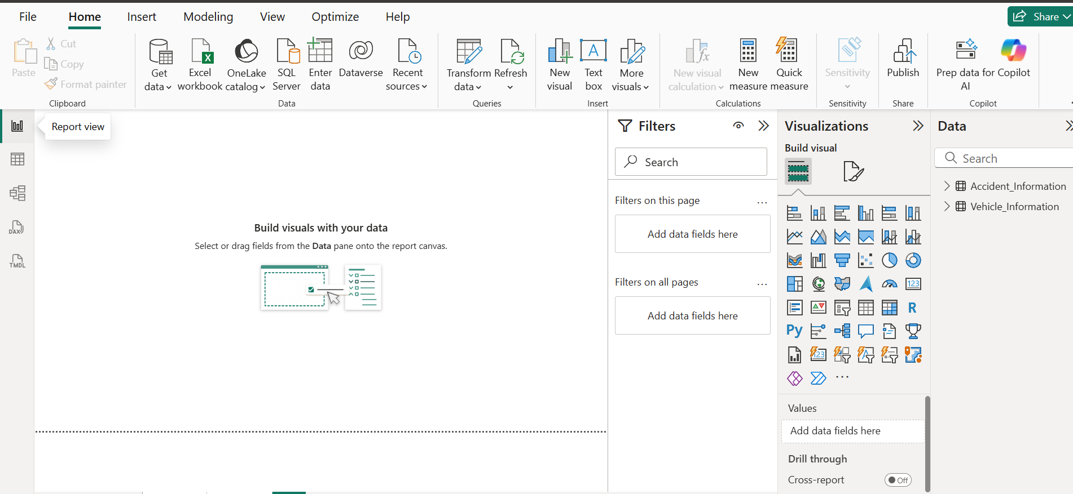

1. Combine multiple visuals (charts, cards, tables, maps) on a single page to create a unified dashboard.



1. Use slicers to filter data dynamically (e.g., by region, category, or date).

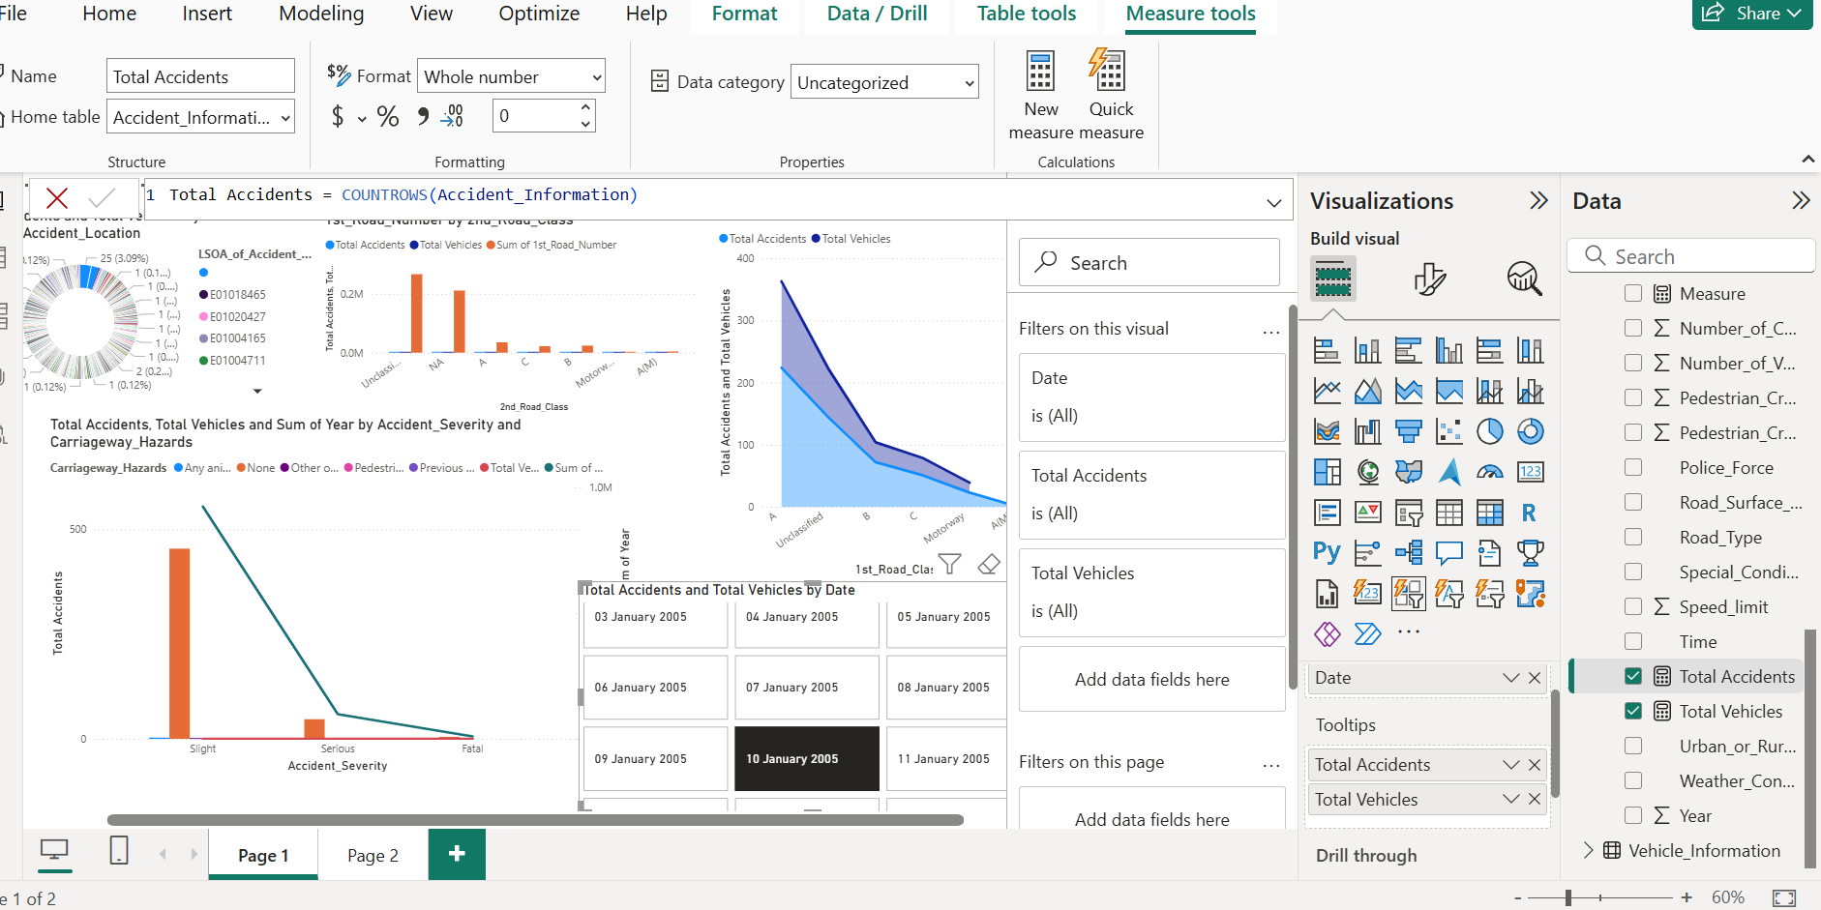

1. Use drill-down features to explore detailed insights within visuals.

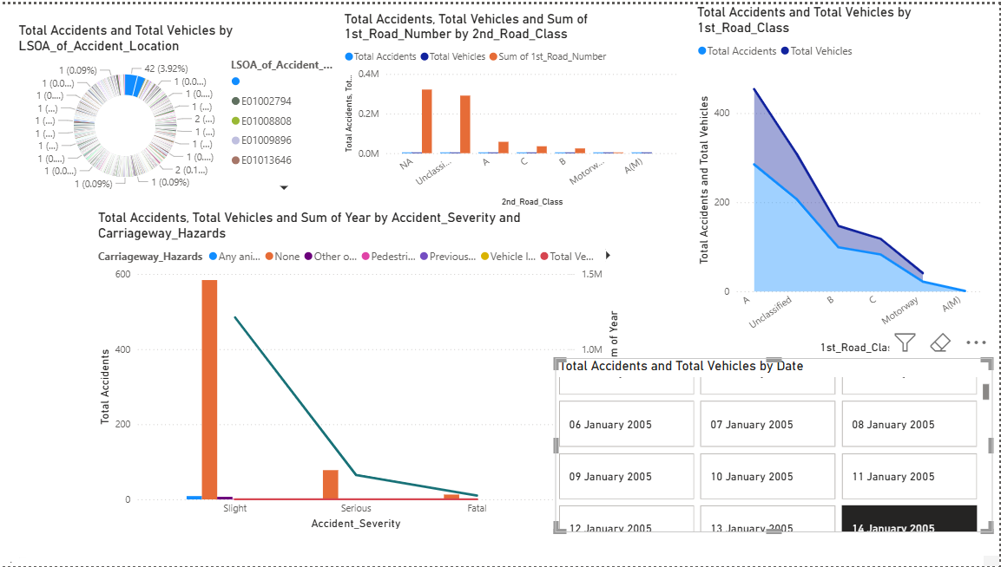

1. Format the visuals for clarity — adjust colors, labels, and titles for better presentation.

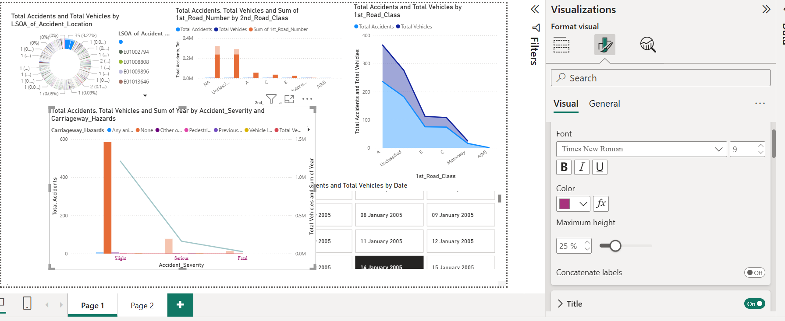

1. Save the Power BI dashboard.

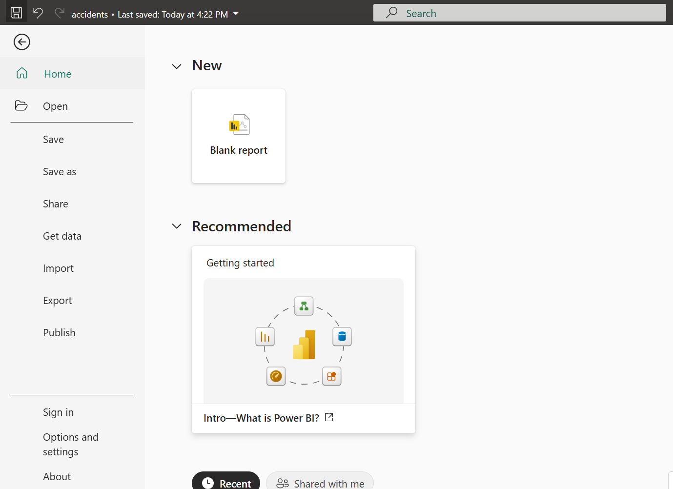

**Result:**  
An interactive **Power BI dashboard** was successfully created and used for **data analysis**, helping visualize trends, compare metrics, and draw meaningful business insights.

|  |  |
| --- | --- |
| Performance (25) |  |
| Viva Voce (10) |  |
| Record (15) |  |
| Total (50) |  |

|  |  |
| --- | --- |
| **Exercise 15**  **Date:** | **Presentation of a case study** |

### **AIM:**

To present a case study for **Sales Performance Analysis** using **Power BI Desktop**

### **The Challenge:**

A retail company operates across multiple regions and sells various products in categories like Electronics, Clothing, Home Appliances, and Furniture. Management wanted to understand:

* How well the sales team is performing.
* Which products or categories are generating maximum revenue.
* Which regions contribute most to sales and profit.
* Seasonal trends in sales.
* Customer preferences and buying patterns.

The company had data scattered across multiple sources including transaction records, customer databases, and product catalogs. Analyzing this manually was time-consuming and prone to errors.

### **The Solution:**

Using **Power BI Desktop**, the sales team and management aimed to answer key questions:

* What is the total sales revenue and profit?
* Which products and categories are the top performers?
* Which regions are generating the most sales?
* What is the month-wise and quarter-wise trend of sales?
* Which customers contributed the most revenue?
* Are there products or regions underperforming compared to expectations?
* How does the profit margin vary across products, categories, and regions?

**Extra Features Implemented:**

* A **menu-driven dashboard** allowing users to navigate between reports on sales, products, customers, and regions.
* **Overview of sales** by product category and region.
* **Detailed analysis of top customers** and their purchase patterns.
* **Insights based on seasonal trends**, highlighting peak and low sales months.
* KPI cards showing Total Sales, Total Profit, and Average Profit Margin.
* Interactive filters/slicers for year, region, product category, and customer segment.
* Drill-down visuals to explore deeper insights, e.g., product-wise sales within a category.

### **OUTPUT:**

### 

### **RESULT:**

The **Sales Performance Analysis** case study was successfully performed. Using Power BI, management gained clear insights into revenue-generating products, high-performing regions, seasonal trends, and customer preferences. The dashboard enabled quick decision-making for marketing strategies, inventory management, and sales planning.

|  |  |
| --- | --- |
| Performance (25) |  |
| Viva Voce (10) |  |
| Record (15) |  |
| Total (50) |  |